**Pacing of foraminifer and nannofossil turnover by Milankovitch grand cycles**

Abdullah Khan Zehadyb, James G. Ogga,b,*, Barry Fordhamc

*aState Key Laboratory of Biogeology and Environmental Geology, School of Earth Sciences, China University of Geosciences, Wuhan 430074, Hubei, P.R. China*

*bDepartment of Earth, Atmospheric and Planetary Sciences, Purdue University, 550 Stadium Mall Drive, West Lafayette, Indiana, 47907-2051, USA*

*cResearch School of Earth Sciences, Australian National University, Acton, ACT, Australia*

E-mail addresses: [*azehady@purdue.edu*](mailto:azehady@purdue.edu)(A. K. Zehady), *jogg@purdue.edu* (J. Ogg), fordham@anu

***Keywords***: Planktonic foraminifer, Calcareous Nannofossil, Stratigraphic range, Biostratigraphy, Earth History, Past Climate

**Highlights**

Speciation and extinction events from Lineage and morphospecies tree during Cenozoic.

Speciation and extinction events of Calcerous nannofossils during Cenozoic.

Detection of Astronomical cycles (1.3 – 2.4 myr)

Correlation with climate proxy data.

Similarity/dissimilarity in foraminifer and nannofossil evolution over time.

Relationship between global climate and evolution of marine organisms

**Abstract**

Foraminifer and nannofossils are the most widely available marine organisms. We used the origination/speciation and extinction events to count evolutionary turnover to create a turnover timeseries data for entire Cenozoic for both foraminifer and nanno-fossil (# number of species). We found weak/strong connection with Milankovitch cycles which have been shown to affect climatic events in a macroscale. Obliquity minima and eccentricity minima are linked with ice sheet expansion and cooling. The turnover peaks can be aligned with oxy-18 events from Oligocene till Miocene and early Pleistocene which give us evidence for the climate-turnover hypothesis for marine microfossils.

**1. Introduction**

**a) Discuss about the importance of forams and nannos as index fossils**

**b) Point to the past reference where Milankovitch grand cycles were identified for parts of the timescale**

**c) Point to the macro-evolutionary result (specially the PNAS pacing paper with graptoloid, nature mammal macro-evolution paper) which suggest cyclicity**

**d) Underlying cause for climate change induced by grand cycles (orbital rotation)**

Foraminifera are the most thoroughly researched marine organisms because of their outstanding fossil record. They have great significance in the discovery of earth history as they capture geochemical information about past ocean chemistry and can help us infer past earth climate, geologic and ecologic environments. They are members of a phylum of single celled eukaryotic organisms which can flourish in all marine environments. Foraminifera are classified into two main categories: a) Planktonic foraminifera which lack the ability to float against the current of an water body and b) Benthic foraminifera which belong to the community of organisms that live near marine or freshwater sedimentary environment (e.g. sands, muds, rocks) at the bottom of the sea, rivers and lakes. The ecological success of foraminifera can be attributed to their ability to move and capture food (small organism like bacteria, diatom) using thread-like pseudopods extended from the cell body. The most important feature of the foraminiferal cell is the shell which can have diverse morphological shapes depending on the species. These shells are made of calcium carbonate and are fundamental components of many rocks. For example, The pyramids in Egypt are made up of limestone containing largest foraminifer species named Nummulite. The morphological differences in test shells are used to classify the foraminifers. Because the development of the outer shell depend on the environment they try to adapt, foraminifer test shells of extant species found in foraminifer samples provide us the information to reconstruct the ecological habitats and environment too. Foraminifer samples collected from sediments can be compared with similar living foraminifera and past environment can be de deduced. Diversity of extinct species, shell type ratio, shell chemistry can be used as powerful tools too. Scientists have used foraminifer to identify past global temperature, measure sea level and ocean depth, study how the shorelines and tropical regions have changed over time. The outstanding fossil record of foraminifera can help us study the evolutionary history and establish connection between the external climatic events and the effect in the speciation and extinction process of these species.

Calcareous nannofossils include coccolith and coccolithophores. Coccolith are plates made of limestone(calcium carbonate) formed by single celled plant-like organism called coccolithophores. After death of these organisms, the coccolith plates get separated from the coccosphere and preserved in sedimentary rocks. The skeletons of coccolithophores are vastly available in marine deposits and are one of the major rock components (e.g. chalk of island Rugen in Baltic sea). These nannofossil, due to their small size, are well distributed across all habitats and thus can be used similarly as foraminifer to study paleo climate and their abundance and diversity make them amazingly useful for macroevolution studies.

Microfossil appearance ages and diversity rate information are heavily informative in oil and gas reservoir exploration. Using benthic foraminifera, Planktonic foraminifera and nannofossils, petroleum industries correlated time in deep wells and constructed global Cenozoic timescales. This paper contributes further to the study of finding links between climatic events due to planetary rotation and their effect on marine species and gives us more insight in answering macroevolutionary questions.

In this paper, we are focusing on the evolution of Planktonic foraminifer and calcareous nannofossil during the Cenozoic era(~65 million years) / Oligocene ~ Miocene. We have found more evidence to prove the climate-turnover hypothesis in the evolutionary data of foraminifer and nannofossil. Evolution of foraminifer and nannofossils show similar trends, the burst of the origination and extinction of these species are highly correlated. We can see cyclic patterns in their turnover timeseries. The cycles (around 2 myr) has been found in many segments of geologic time in different sources. We have studied the evolutionary range of each of the foram and nannofossil species and calculated the temporal speciation and extinction events. Interestingly, such speciation and extinction events show quasi-cyclicity which are believed to be produced by the amplitude modulation of various Milankovitch cycles. What gives birth to new species versus what causes the extinction of existing species?

We have compiled (extended from an existing table from ?? paper ) in the table the studies which show the cyclicity/periodicity induced by astronomical forcing in different geochemical proxies. The studies are sorted by the geologic time period the proxies are collected for.

Table: Studies showing grand cycle (1.2-6Myr)

|  |  |  |  |
| --- | --- | --- | --- |
| Age | Cycle | Proxy | Reference |
| 0-24 Ma | ~1.2-2.5 Myr | Rodent turnover | Van Dam et al. (2006) |
| 0-35 Ma | ~1.8-2.4 Myr | Oxygen isotope of benthic foraminifera | De Vleeschouwer et al. (2017) |
| 0-80 Ma | ~1.2-2.4 Myr | Carbon and oxygen isotope of benthic foraminifera | Cramer et al. (2009) |
| 11.5-15.2 Ma | ~2.4 Myr | L* of lake sediments | Abels et al. (2010) |
| 14-36 Ma | ~2.4 Myr | Sedimentary facies of lake sediment | Valero et al. (2014) |
| 47-53 Ma | ~2.4 Myr | Fe intensity of pelagic marine succession | Westerhold et al. (2012) |
| 53-57 Ma | ~2.25 Myr | Bulk carbonate d13C and magnetic susceptibility (MS) records across the Elmo horizon | Lourens et al. (2005) |
| 60-84 Ma | ~2.5 Myr | Carbonate content of pelagic marine succession | Herbrt et al. (1999) |

The main contribution of the paper:

1. A comprehensive table for speciation, extinction and turnover for every 100K years for 340 cenozoic macroperforate planktonic foraminifer with FAD, LAD, lifespan grouped by family, genus, morphogroup end ecogroup.
2. Speciation, extinction and turnover for every 100K years for lineage with FAD, LAD, lifespan grouped by morphogroup end ecogroup.
3. Speciation, extinction and turnover for every 100K years for Nannofossil with FAD, LAD, lifespan grouped by family, genus.
4. Relationship of speciation, extinction, turnover of foraminiferal morphospecies and nannofossil species with marine oxy-18 events from Paleocene up until early Pliestocene
5. Investigation of grand cycle (1.2 Myr) in fossil turnover data and further evidence for climate-turnover hypothesis

**2. Dataset**

**1.** Which dataset?

**2.** Source of data

**3.** Why is this dataset used? What’s the significance of it? Why not something else?

**4.** Descriptive statistics of the dataset – lifespan (mean, min, max)

**5.** Astronomically tuned timescale?

We wanted to focus on the macroevolutionary trend in the early Cenozoic era. To study evolutionary trends over millions of years, it is required to have access to a group of organisms which was prevalent throughout the entire time in almost all ecological habitat.

Fossil records come with incompleteness due to (a) some taxa are not studied extensively (b) some geologic time period are undersampled. Planktonic foraminifera, on the other hand, has the most complete fossil record. Planktonic foraminifer lies in the base of the food pyramid and has been widely available across different marine environment throughout the whole Phanerozoic. Aze et al have looked into multiple studies of foraminifer fossil records and compiled a dataset of evolutionary ranges of foraminifer fossils for the whole Cenozoic. The grouping mechanism of the organisms relied mainly on the morphological characteristics and further grouped by ecological information. Genetic similarity or dissimilarity between organisms were not considered as it is difficult to obtain ancient DNA. The dataset provides two main evolutionary tree: one represents the lineage tree and the other is more elaborative morphospecies tree. We first used the morphospecies tree to perform our macroevolutionary analysis as our primary concern is the rate of change in the speciation, extinction and turnover which can be benefitted if we have more data points per million years. Every morphospecies in the tree has a first and last appearance datum which creates the evolutionary range. There are 340(339) unique morphospecies under 48 unique genera which are grouped by 7 families: "Hedbergellidae", "Globigerinidae", "Truncorotaloididae", "Hantkeninidae", "Globoquadrinidae", "Globorotaliidae", "Pulleniatinidae". The sheet “PF_FAD_LAD” shows the full list of morphospecies with their binomial name, FAD(First Appearance Datum), LAD(Last Appearance Datum), Genus, Family, Morphogroup and Ecogroup. Mean species lifespan for all the morphospecies is 6.481 Myr. Globoquadrinidae family has the maximum mean life span (13.719 Myr) whereas the short-lived family is Pulleniatinidae with mean life span 2.701 Myr. The full list of mean life span, mean start of lifespan and mean end of lifespan results are provided in the 1st table of “PF_stat” sheet in the supplementary file. The greatest number of morphospecies, total 140 species, are under the family Globigerinidae which shows the mean life span of 9.619 Myr. The longest living foraminifer morphospecies is the “Catapsydrax unicavus” under Globigerinidae family which had a lifespan of 38.02 Myr (FAD=55.56 Myr, LAD=17.54Myr). On the other hand, the shortest living morphospecies Globigerinella adamsi is a living foraminifer which came into existence 10,000 years (FAD=0.01Myr, LAD=0Myr) ago. Aze et al. and later Barry et al. have successfully categorized the foraminifer morphospecies into 19 Morphogroups (based on their test shell structure difference) and 6 Ecogroups . Morphogroup 2 and 7 have the highest number of morphospecies (80 and 52 respectively). Ecogroup 1 and 3 have the highest number of morphospecies (110 and 107 respectively). We have tabulated number of species, mean lifespan, mean start and end of lifespan in the PF_stat sheet for all morphogroup and ecogroup. Out of 19 Morphogroups, only 10 Morphogroup(M1-flat, M2-globular, M3-globular with supplementary apertures, M4-spherical, M5-clavate, M6-planispiral, M7-globluar, M14-globorotaliform,keeled, M15-globorotaliform, anguloconical, M16-globorotaliform, non-killed) still exist till the present age, whereas the rest of the 9 morphogroups have got extinct (M8-globular, keeled, M9-planispiral, M10-tubulospinate, M11-keeped spines, M12-turborotaliform, keeled, M13-turborotaliform, non-keeled, M17-muricate, acarininiform, M18-muricocarinate, keeled, M19-muricocarinate, anguloconical) (Figure 2 and and PF_stat sheet Table 2). The extinct morphogroups belong to the 3 families Hedbergellidae, Truncorotaloididaw, Hantkeninidae and the other five families are still present. Out of the 6 ecogroups, the sixth ecogroup E6-upwelling/high got extinct in 15.1 Myr ago. The high latitude foraminifers (E5-high-latitude) has the maximum mean lifespan (16.033 Myr), whereas the thermocline Ecogroup has the minimum lifespan of 6.782 Myr. The E1-With Symbionts ecogroup has the highest number of species (110), the E3-thermocline group also has almost equally abundant (107) species. There are only 3 species which live in high latitude and 9 species in upwelling/high habitat. We can also see the distribution of species by their morphogroup in the Table 2 of PF_stat sheet.

Table 1: Planktonic Foraminifer statistics by family

|  |  |  |  |  |
| --- | --- | --- | --- | --- |
| **Family** | **# of Species** | **Mean Start of Lifespan** | **Mean End of Lifespan** | **Mean Lifespan** |
| Hedbergellidae | 29 | 52.290 | 46.909 | 5.381 |
| Globigerinidae | 140 | 31.836 | 22.216 | 9.619 |
| Truncorotaloididae | 69 | 54.898 | 49.036 | 5.863 |
| Hantkeninidae | 16 | 42.928 | 38.804 | 4.125 |
| Globoquadrinidae | 16 | 29.300 | 15.581 | 13.719 |
| Globorotaliidae | 64 | 8.557 | 4.600 | 3.957 |
| Pulleniatinidae | 6 | 5.070 | 2.370 | 2.701 |
| Total: | 340 | 32.126 | 25.645 | 6.481 |

We have also tabulated all the foraminifer lineages in the sheet named “PFL_FAD_LAD”. The naming convention for each of the lineage is described in Aze et al. There are 212 lineages determined from the 340 morphospecies. They are also categorized by their morphogroup and ecogroup. The number of species and lifespan statistics for each of the groups are provided in “PFL_stat” sheet. PFL_stat shows the start, end and mean lifespan for all 19 morphogroup and 6 ecogroup for all lineages.

BP Gulf of Mexico paper has created a standard framework to detect the biozonation using nannofossils. For some genera, the family name is missing and the class or phylum name was used. And in some case “-“ is used. The nannofossils in our study are under the following families: "-", "Calcidiscaceae", "Ceratolithaceae", "Coccolithaceae", "Discoasteraceae", "Helicosphaeraceae", "Noelaerhabdaceae", "Pontosphaeraceae", "Sphenolithaceae". Discosteraceae family has the highest (95) number of species where as Pontosphaeraceae and Calcidiscaceae have only 2 or 3 species under them respectively.

Table 2: Number of species and Lifespan of Nannofossils by Family/Class/Phylum

|  |  |  |  |  |
| --- | --- | --- | --- | --- |
| **Family** | **# of Species** | **Mean Lifespan** | **Start of Lifespan** | **End of Lifespan** |
| Ceratolithaceae | 25 | 7.60 | 61.61 | 0.21 |
| Discoasteraceae | 95 | 4.48 | 65.40 | 4.03 |
| Sphenolithaceae | 42 | 10.79 | 54.17 | 18.77 |
| Calcidiscaceae | 3 | 10.74 | 26.15 | 0.00 |
| Noelaerhabdaceae | 31 | 11.69 | 55.86 | 14.32 |
| Helicosphaeraceae | 35 | 9.54 | 55.86 | 11.91 |
| Coccolithaceae | 6 | 3.78 | 55.96 | 3.63 |
| Pontosphaeraceae | 2 | 6.95 | 27.81 | 18.61 |
|  | 239 | 8.20 | 50.35 | 8.94 |

The evolutionary first appearance and last appearance ages are

calibrated to the high precision astronomically tuned timescale

provided in the Geologic TimeScaleCreator software. The astronomical solution provided by Laskar et al, 2004 has been used to create the timescale of Cenozoic era which has been later significantly enhanced to ensure high precision. The high frequency cyclostratigraphy data from International Ocean Drilling Program (IODP) Legs are also used to ensure the accuracy of Cenozoic timescale.

Median life span for nannos is 2.83 Myr.

Lineage and Morphospecies evolutionary tree from Fordham and Zehady et al(2018). Phylogenetic tree data and graphs provided by Aze & others.

Calcerous nannofossil data from BP gulf of Mexico paper.

Oxygen-18 isotope data (Cramer 2009)

﻿﻿Morphospecies were also assigned to ecogroups, based

on geochemical information from foraminiferal calcite and geographical information about environmental preference. Carbon (δ13C) and oxygen (δ18O) isotopic signatures of foraminiferal tests partly reflect the ambient water chemistry

at the time of calcification and also biotic and kenetic fractionations of dissolved inorganic carbon from which the foraminifera construct their tests

﻿The carbon isotope ratio varies with water mass and depth in

﻿the water column, with heavier ratios being found in surface waters where algal photosynthesis preferentially removes the light isotope, which is reintroduced at depth through respiration.

Photosymbiosis, size of the test

﻿The oxygen isotopic ratio reflects the isotopic ratio of sea

water with a significant temperature-related fractionation. Foraminifera that live in warmer surface waters have lighter (δ18O) than those that calcify in colder deeper water.

*It is anticipated that morphogroup information will*

*aid future research assessing the iterative nature of morphological characterswithin lineages and across the clade*

*as awhole, and allow us to assess the extent and distribution of homoplasies within the phylogenies. Ecogroup information will also provide means to investigate how ecological niche space is occupied throughout the whole Cenozoic and during periods perturbed by significant environmental changes, such*

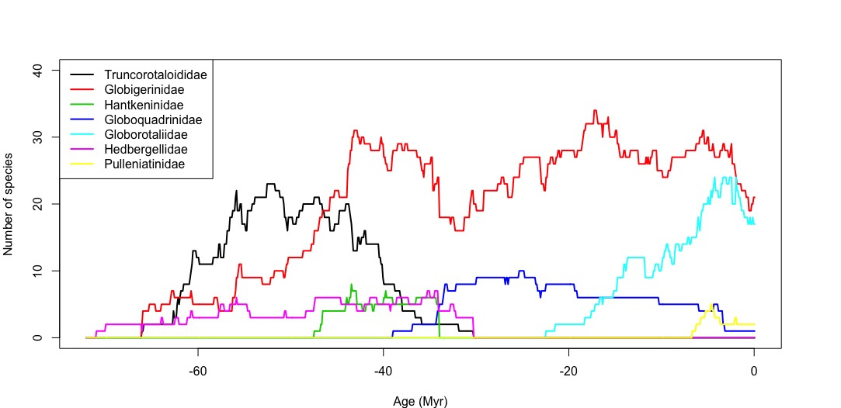

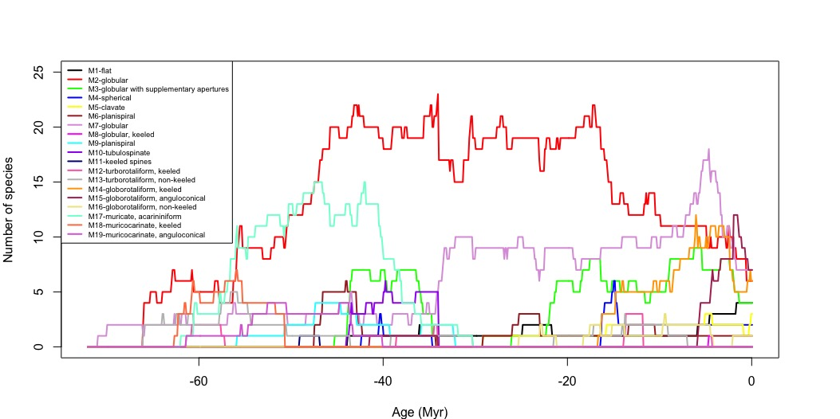

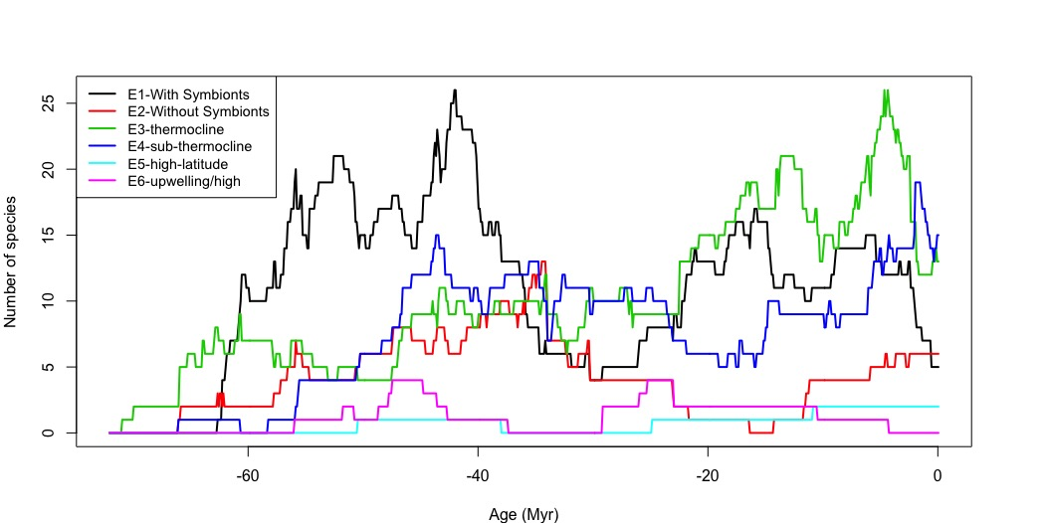

Figure: Evolution of foraminifer species throughout Cenozoic grouped by (a) Family (b) Morphogroup (c) Ecogroup

**3. Methods**

Long term astronomical cycle have been discovered to influence the atmosphere and ecology of our planet. The principal planetary rotations are eccentricity, obliquity and precession. Eccentricity determines the shape of the orbit earth is following to circle around the sun. Obliquity is the tilt of our planet with respect to the solar plane. Precession refers to earth’s own rotation around the vertical axis. Variation in eccentricity changes the distance between sun and earth’s hemisphere and thus the received solar energy through sunlight is dependent on eccentricity cycle which has been measured to be 100 Kyr (on the minor axis) and 410Kyr (on the major axis). These two cycles interact and show a longer 0.97 and 2.32 Myr cycle that cause amplitude modulation of precession or obliquity cycle.

We intend to understand the evolutionary changes happened in foraminifer and nannofossils. We have produced timeseries for speciation (pseudospeciation) and extinction (pseudoextinction) of foraminifer morphospecies and lineage (citation??). The foraminifer morphospecies and lineages have shown different lifespan as we can see in the figure, that can be categorized by family, morphogroup and ecogroup. We can see pattern and cyclical occurrence of burst of speciation or extinction.

To get better granularity, we divide the whole Cenozoic into many pseudolevels each separated by 100 Kyr (0.1 Myr). Our data mining algorithm parses through the timeseries of speciation (FAD) and extinction (LAD) and count them individually for each pseudolevel. The turnover timeseries is calculated by taking the sum of speciation and extinction (FAD + LAD) for each pseudolevel. In figure, we have shown the speciation (green), extinction (red) and turnover (black) curve for foraminifer morphospecies, lineages and nanno fossils. Mean lifespan timeseries is calculated by taking the sum of lifespan till current pseudolevel for all the living species in that lifespan. For each of our species collection, we have plotted the number of existing species and mean lifespan together. We can see small bulges which shows how increasing number of existing species drive the mean lifespan per pseudolevel down in most cases.

Do I want to analyze LAD – FAD and LAD/FAD or FAD/LAD too?? (may be not!!)

Correlation co-efficient using pearson correlation between three timeseries.

Mean species lifetime: How many species are there in my dataset?

What is the mean species lifetime for the planktonic foraminifer fossils

What is the mean species lifetime for the nannofossil dataset?

Characteristic of fossil (investigation whether any particular foraminifer has links to dryness, humidity)

Why certain species might have died during certain cold phase? Any patterns

Which species has the longest life? Versus which species has the shortest life span…

Hidden markov model: turnover probability. -> speciation proability, extinction probability, turnover probability.

Cycle analysis using multitaper spectral analysis. Significance test with autoregression (AR) and harmonic variance ratio F-test.

For robust analysis, hidden markov model and AIC based model selection (pacing paper by Myers)

**Figure (a) foraminifer morphospecies (b) foraminifer lineage (c) nannofossil**

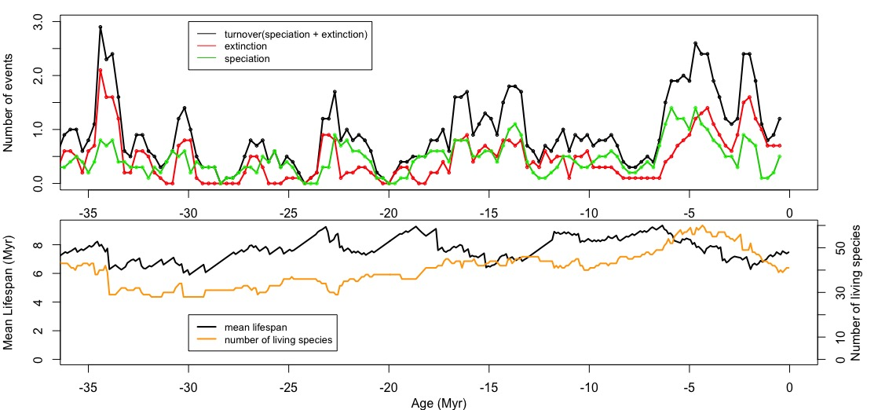

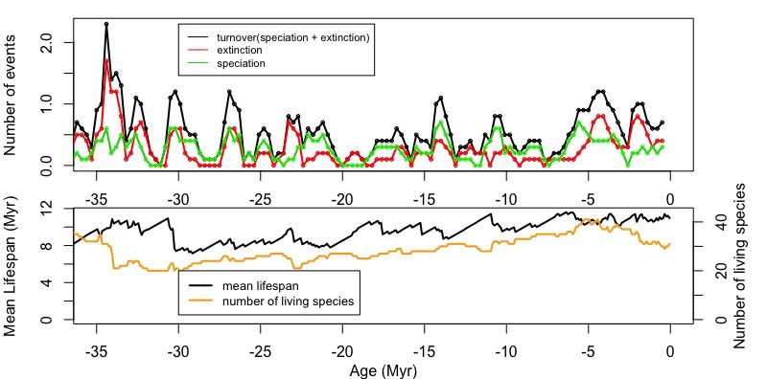

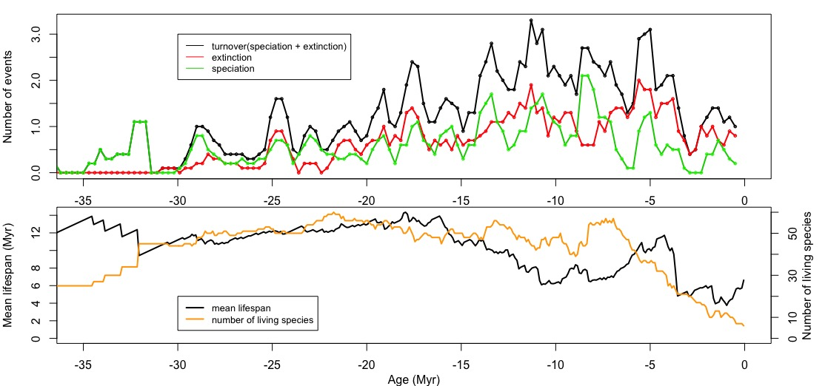

1. **Results**

Figures

1. Speciation events of planktonic foraminifer(PF)
2. Extinction events of PF
3. Turnover events of PF
4. Speciation events of calcerous nannofossils(NN)
5. Extinction events of NN
6. Turnover events of NN
7. Mean lifespan (currently existing) + diversity for PF
8. Mean lifespan (currently existing) + diversity for NN

1. Temperature (Oxygen-18) timeseries
2. Hidden markov model figures
3. Spectral power for frequency + period with significance level

Turnover events <-> eccentricity maxima (0.97 Myr), obliquity node(1.2 Myr )

1. **Discussion**

What does the speciation + extinction of forams and nannofossil tell us about the past global climate? What caused the speciation and extinction? Can we see matches with already known major events?

﻿Milankovitch grand cycles (7) are astronomical rhythms as- sociated with the amplitude modulation of Earth’s climatic precession cycle and axial obliquity cycle. During the Late Cenozoic, the amplitude modulation of precession by eccen- tricity results in a 2.4-My cycle in addition to the well-known cycles of 405,000 and ∼100,000 y; the long-period obliquity amplitude modulation is ∼1.2 My (Fig. 1) (8, 9). These relate to ﻿g4-g3, the orbital perihelion precession rates of Mars and Earth, and s4-s3, the orbital inclination rates of Mars and Earth, re- spectively. These grand cycles have been implicated as controls on Late Cenozoic ice sheet history (10) and sea-level variability into the Mesozoic (11). The environmental impact of the grand cycles is to produce long-term “nodes” of stability (e.g., little dif- ference in climate between maximum and minimum of obliquity) that alternate with times of maximum volatility (e.g., strong cli- matic differences between maximum and minimum of obliquity). Whereas this multimillion year control on environmental stability has obvious implications for biological evolution, its presence has not been clearly detected in evolutionary rate data, except in the case of the Neogene mammalian record (6). A major obstacle in this regard has been the availability of records of appropriate duration and sampling frequency to permit a robust evaluation. Graptoloids

1. **Conclusions**

Contribution of the paper

**Acknowledgements**

**References**

1. Aze, T., Ezard, T.H., Purvis, A., Coxall, H.K., Stewart, D.R., Wade, B.S., et al., 2011. A phylogeny of Cenozoic macroperforate planktonic foraminifera from fossil data. *Biological Reviews of the Cambridge Philosophical Society*. 86(4): 900-27. doi:10.1111/j.1469-185X.2011.00178.x.
2. Bergen, J.A., de Kaenel, E., Blair, S.A., Boesiger, T.M. and Browning, E., 2017. Oligocene-Pliocene taxonomy and stratigraphy of the genus Sphenolithus in the circum North Atlantic Basin: Gulf of Mexico and ODP Leg 154. *Journal of Nannoplankton Research*, *37*(2-3), pp.77-112.
3. Blair, S., Bergen, J., de Kaenel, E., Browning, E., and Boesiger, T., 2017, Upper Miocene-Lower Pliocene taxonomy and stratigraphy in the circum North Atlantic Basin: Radiation and extinction of Amauroliths, Ceratoliths, and the D. quinqueramus lineage: Journal of Nannoplankton Research, v. 37, no. 2-3, p. 113–144.
4. Boesiger, T., de Kaenel, E., Bergen, J., Browning, E., and Blair, S., 2017, Oligocene to Pleistocene taxonomy and stratigraphy of the genus Helicosphaera and other placolith taxa in the circum North Atlantic Basin: Journal of Nannoplankton Research, v. 37, no. 2-3, p. 145–175.
5. Browning, E., Bergen, J., Blair, S., Boesiger, T., and de Kaenel, E., 2017, Late Miocene to Late Pliocene taxonomy and stratigraphy of the genus Discoaster in the circum North Atlantic Basin: Gulf of Mexico and ODP Leg 154: Journal of Nannoplankton Research, v. 37, no. 2-3, p. 189–214.
6. Fordham, B.G., Aze, T., Haller, C., Zehady, A.K., Pearson, P.N., Ogg, J.G., and Wade, B.S., 2018. Future-proofing the Cenozoic macroperforate planktonic foraminifera phylogeny of Aze & others (2011). *PLOS One*, 13(10): e0204625.
7. De Vleeschouwer, D., Vahlenkamp, M., Crucifix, M. and Pälike, H., 2017. Alternating Southern and Northern Hemisphere climate response to astronomical forcing during the past 35 my. *Geology*, *45*(4), pp.375-378.
8. Cramer, B.S., Toggweiler, J.R., Wright, J.D., Katz, M.E. and Miller, K.G., 2009. Ocean overturning since the Late Cretaceous: Inferences from a new benthic foraminiferal isotope compilation. *Paleoceanography*, *24*(4).
9. Abels, H.A., Aziz, H.A., Krijgsman, W., Smeets, S.J. and Hilgen, F.J., 2010. Long-period eccentricity control on sedimentary sequences in the continental Madrid Basin (middle Miocene, Spain). *Earth and Planetary Science Letters*, *289*(1-2), pp.220-231.
10. Valero, L., Garcés, M., Cabrera, L., Costa, E. and Sáez, A., 2014. 20 Myr of eccentricity paced lacustrine cycles in the Cenozoic Ebro Basin. *Earth and Planetary Science Letters*, *408*, pp.183-193.
11. Westerhold, T., Röhl, U. and Laskar, J., 2012. Time scale controversy: Accurate orbital calibration of the early Paleogene. *Geochemistry, Geophysics, Geosystems*, *13*(6).
12. Herbert, T.D., 1999. Toward a composite orbital chronology for the Late Cretaceous and Early Palaeocene GPTS. *Philosophical Transactions of the Royal Society of London. Series A: Mathematical, Physical and Engineering Sciences*, *357*(1757), pp.1891-1905.
13. Sprovieri, M., Sabatino, N., Pelosi, N., Batenburg, S.J., Coccioni, R., Iavarone, M. and Mazzola, S., 2013. Late Cretaceous orbitally-paced carbon isotope stratigraphy from the Bottaccione Gorge (Italy). *Palaeogeography, Palaeoclimatology, Palaeoecology*, *379*, pp.81-94.
14. Grippo, A., Fischer, A.G., Hinnov, L.A., Herbert, T.D. and Silva, I.P., 2004. Cyclostratigraphy and chronology of the Albian stage (Piobbico core, Italy).
15. Huang, C., Hinnov, L., Fischer, A.G., Grippo, A. and Herbert, T., 2010. Astronomical tuning of the Aptian Stage from Italian reference sections. *Geology*, *38*(10), pp.899-902.
16. Martinez, M. and Dera, G., 2015. Orbital pacing of carbon fluxes by a∼ 9-My eccentricity cycle during the Mesozoic. *Proceedings of the National Academy of Sciences*, *112*(41), pp.12604-12609.
17. Martinez, M. and Dera, G., 2015. Orbital pacing of carbon fluxes by a∼ 9-My eccentricity cycle during the Mesozoic. *Proceedings of the National Academy of Sciences*, *112*(41), pp.12604-12609.
18. Boulila, S., Galbrun, B., Hinnov, L.A., Collin, P.Y., Ogg, J.G., Fortwengler, D. and Marchand, D., 2010. Milankovitch and sub-Milankovitch forcing of the Oxfordian (Late Jurassic) terres noires formation (SE France) and global implications. *Basin Research*, *22*(5), pp.717-732.
19. Ikeda, M., Tada, R. and Ozaki, K., 2017. Astronomical pacing of the global silica cycle recorded in Mesozoic bedded cherts. *Nature communications*, *8*, p.15532.
20. Kent, D.V., Olsen, P.E. and Muttoni, G., 2017. Astrochronostratigraphic polarity time scale (APTS) for the Late Triassic and Early Jurassic from continental sediments and correlation with standard marine stages. *Earth-Science Reviews*, *166*, pp.153-180.
21. Muttoni, G., Kent, D.V., Olsen, P.E., Stefano, P.D., Lowrie, W., Bernasconi, S.M. and Hernández, F.M., 2004. Tethyan magnetostratigraphy from Pizzo Mondello (Sicily) and correlation to the Late Triassic Newark astrochronological polarity time scale. *Geological Society of America Bulletin*, *116*(9-10), pp.1043-1058.
22. Van Dam, J.A., Aziz, H.A., Sierra, M.Á.Á., Hilgen, F.J., van den Hoek Ostende, L.W., Lourens, L.J., Mein, P., van Der Meulen, A.J. and Pelaez-Campomanes, P., 2006. Long-period astronomical forcing of mammal turnover. *Nature*, *443*(7112), p.687.
23. Lourens, L.J., Sluijs, A., Kroon, D., Zachos, J.C., Thomas, E., Röhl, U., Bowles, J. and Raffi, I., 2005. Astronomical pacing of late Palaeocene to early Eocene global warming events. *Nature*, *435*(7045), p.1083.
24. Crampton, J.S., Meyers, S.R., Cooper, R.A., Sadler, P.M., Foote, M. and Harte, D., 2018. Pacing of Paleozoic macroevolutionary rates by Milankovitch grand cycles. *Proceedings of the National Academy of Sciences*, *115*(22), pp.5686-5691.

**Appendix**



**Figure (Foraminifer evolution sorted with FAD from left to right through Cenozoic era grouped colored by family!!??, the second panel shows the number of species with same FADs (100Kyr interval!!??)**



**Figure (Foraminifer evolution sorted from left to right by last appearance through Cenozoic era grouped colored by family!!??, the second panel shows the turnover timeseries.**



**Figure (Nannofossil evolution sorted with FAD from left to right through Cenozoic era grouped colored by family!!??, the second panel shows the number of species with same FADs (100Kyr interval!!??)**



**Figure (Nannofossil evolution sorted by LAD from left to right through Cenozoic era grouped colored by family!!??, the second panel shows the turnover timeseries.**